**A survey about the factors affect students' Mathematical Analysis grade/ 一份关于影响学生数学分析成绩的调查问卷**

第2题：How is your attendance this semester?/ 您这学期的出勤情况？ [单选题]

|  |  |  |  |  |  |  |  |
| --- | --- | --- | --- | --- | --- | --- | --- |
| X\Y | Never missed a class/ 从不缺勤 | Have missed class(es), but missed no more than 2 class/ 缺勤1-2次 | Have missed more than 2 but no more than 5 classes/ 缺勤3-5次 | Have missed more than 5 but no more than 10 class/ 缺勤5-10次 | Have attended class, but missed more than 10 classes/ 有出勤，但缺勤多于10次 | Never attend class/ 从不出勤 | 小计 |
| Period 1-2/ 1-2节 | 21(72.41%) | 7(24.14%) | 0(0%) | 0(0%) | 0(0%) | 1(3.45%) | 29 |
| Period 3-4/ 3-4节 | 27(87.1%) | 2(6.45%) | 2(6.45%) | 0(0%) | 0(0%) | 0(0%) | 31 |

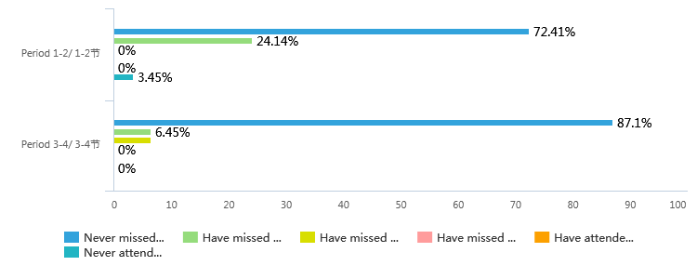

第3题：How often are you late for class this semester?/ 您这学期的迟到情况？ [单选题]

|  |  |  |  |  |  |  |  |
| --- | --- | --- | --- | --- | --- | --- | --- |
| X\Y | Never be late/ 从不迟到 | Have been late but no more than 2 times/ 迟到过1-2次 | Have been late more than 3 times but no more than 5 times/ 迟到过3-5次 | Have been late more than 5 times but no more than 10 times/ 迟到过5-10次 | Have been late more than 10 times/ 迟到超过10次 | Be late for every class/ 每节课都迟到 | 小计 |
| Period 1-2/ 1-2节 | 12(41.38%) | 12(41.38%) | 5(17.24%) | 0(0%) | 0(0%) | 0(0%) | 29 |
| Period 3-4/ 3-4节 | 23(74.19%) | 5(16.13%) | 2(6.45%) | 1(3.23%) | 0(0%) | 0(0%) | 31 |

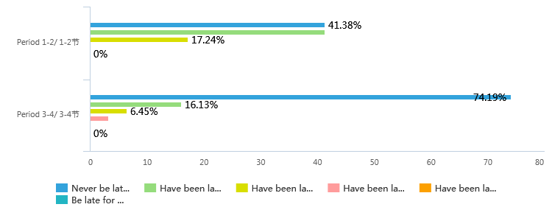

第4题：How is your mental state in class？/ 您上课时的精神状态？ [单选题]

|  |  |  |  |  |  |  |  |
| --- | --- | --- | --- | --- | --- | --- | --- |
| X\Y | Extremely concentrated/ 极其专注 | Attentive/ 认真 | OK/ 还行 | Distracted/ 分心，做其他事情 | Sleepy/ 困倦，昏昏欲睡 | Asleep/ 睡眠模式已开启 | 小计 |
| Period 1-2/ 1-2节 | 2(6.9%) | 9(31.03%) | 11(37.93%) | 4(13.79%) | 3(10.34%) | 0(0%) | 29 |
| Period 3-4/ 3-4节 | 1(3.23%) | 9(29.03%) | 11(35.48%) | 8(25.81%) | 1(3.23%) | 1(3.23%) | 31 |

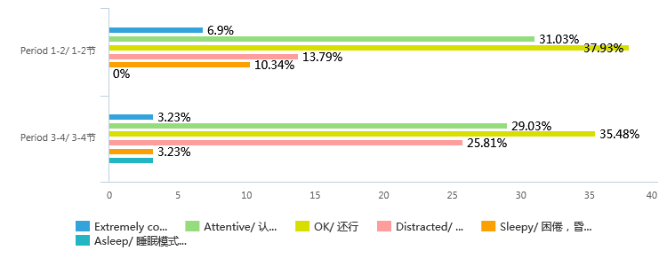

第5题：Can you follow teacher's thinking?/ 您是否能够跟上老师的思路？ [单选题]

|  |  |  |  |  |  |  |
| --- | --- | --- | --- | --- | --- | --- |
| X\Y | Absolutely/ 完全可以 | Mostly/ 通常可以 | Basically/ 基本可以 | Sometimes/ 偶尔可以 | Never/ 这**都在讲什么呀 | 小计 |
| Period 1-2/ 1-2节 | 3(10.34%) | 19(65.52%) | 4(13.79%) | 2(6.9%) | 1(3.45%) | 29 |
| Period 3-4/ 3-4节 | 1(3.23%) | 14(45.16%) | 6(19.35%) | 8(25.81%) | 2(6.45%) | 31 |

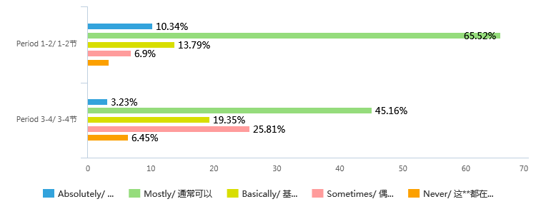

第6题：How often do you finish your homework this semester?/ 您本学期的作业完成情况？ [单选题]

|  |  |  |  |  |  |  |  |
| --- | --- | --- | --- | --- | --- | --- | --- |
| X\Y | Always finish/ 每次都完成 | Have missed but no more than 2 times/ 有1-2次未完成 | Missed more than 2 but no more than 5 times/ 有3-5次未完成 | Missed more than 5 but no more than 10 times/ 有5-10次未完成 | Missed more than 10 times/ 超过10未完成 | Never finish/ 从不完成 | 小计 |
| Period 1-2/ 1-2节 | 28(96.55%) | 0(0%) | 0(0%) | 0(0%) | 1(3.45%) | 0(0%) | 29 |
| Period 3-4/ 3-4节 | 29(93.55%) | 1(3.23%) | 1(3.23%) | 0(0%) | 0(0%) | 0(0%) | 31 |

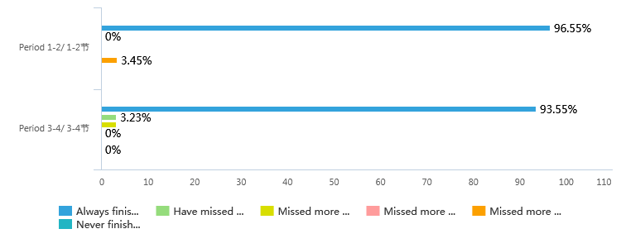

第7题：How difficult is the homework for you?/ 您觉得作业的难度？ [单选题]

|  |  |  |  |  |  |  |
| --- | --- | --- | --- | --- | --- | --- |
| X\Y | Too simple/ 过于简单 | Simple/ 偏简单 | Normal/ 难度适中 | Difficult/ 偏困难 | Too difficult/ 过于困难 | 小计 |
| Period 1-2/ 1-2节 | 0(0%) | 0(0%) | 15(51.72%) | 12(41.38%) | 2(6.9%) | 29 |
| Period 3-4/ 3-4节 | 0(0%) | 1(3.23%) | 16(51.61%) | 14(45.16%) | 0(0%) | 31 |

